Your Gift Letter is on Page 2. Here are some ideas to help you brand yourself with your client gifts.

- USE THIS GIFT LETTER TO ADD MORE VALUE
- Share with your clients the best way to use this gift
- Inform your clients of the quality gift you chose for them
- Personalized system in place to add value to your business

2. PRESENTATION IDEAS TO FIT YOUR STYLE & INCREASE YOUR BRAND:
- Separate the events and don’t bring the gift to the closing table. Instead, mail or pop by after they’ve moved in.
- Add your favorite or a seasonal recipe with the letter
- Pair with a classy cookbook (fitting their style)
- Deliver to your client’s office with a treat to share – get them to talk about you!
- Put in a basket with other goodies

3. TURN GIFTS INTO BRANDING OPPORTUNITIES:
- Closing Gifts
- Referral Thank you
- Appreciation Party / Holiday Gifts
- Auction / Charity donations
- A List Clients & Raving Fans
- Advocate, Referral & Key Partners
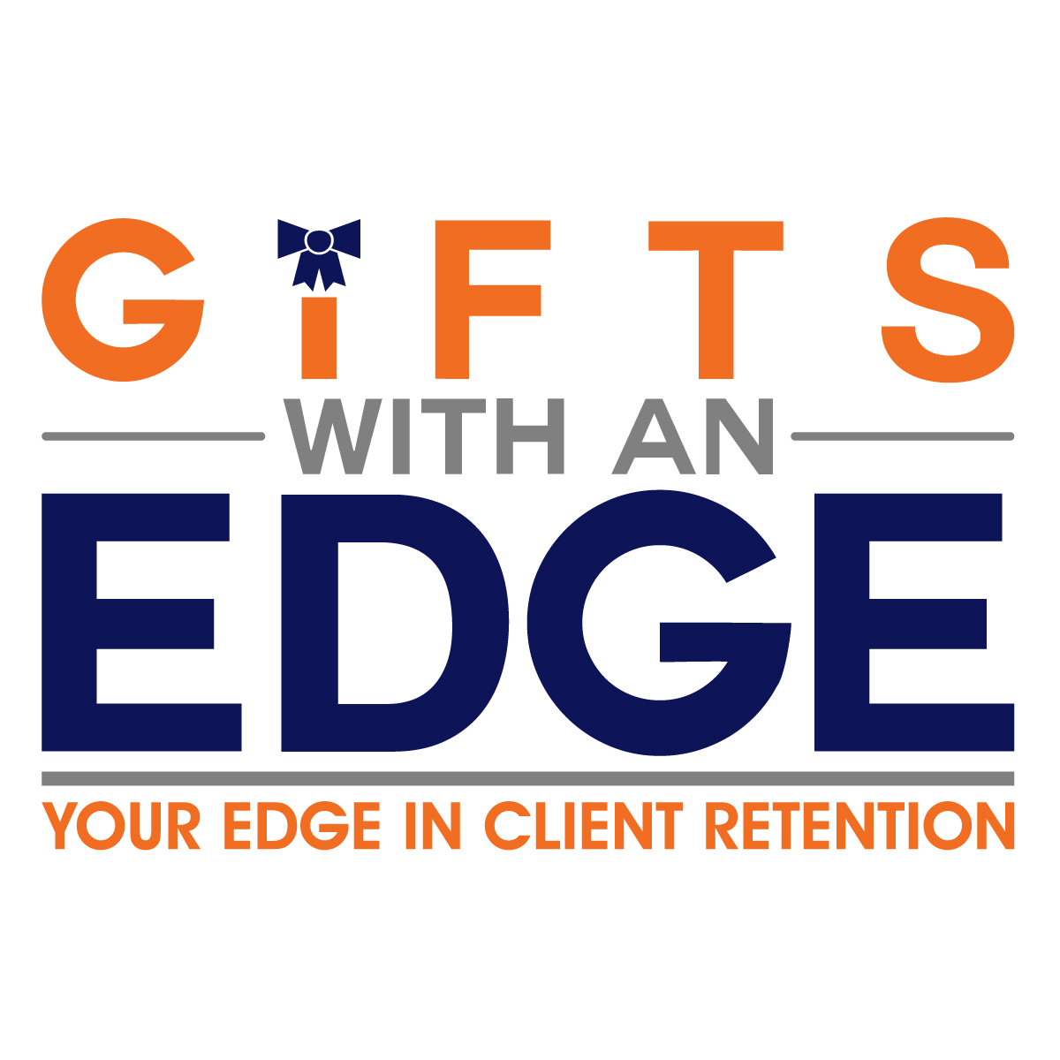
www.GiftsWithAnEdge.com
888.482.8826

CLIENT NAME,

I do my best to offer the highest quality service to my clients and only want to represent the very best. That is why I am giving you the gift of CUTCO. CUTCO is the #1 knife brand in North America and is 100% AMERICAN MADE. Backed by a FOREVER GUARANTEE, this company has been in business since 1949.

I trust you’ll enjoy using them with your family and friends for years to come. Below is a brief description of each knife in your gift.

The Cheese Knife – The Smooth Operator

- Holes on the blades surface helps cheese fall away during cutting
- Use to cut vegetables and fruits
- Use to cut tomatoes and potatoes
- Perforations keep dense foods from sticking

I genuinely appreciate you and your business. I hope your CUTCO will serve your family well, as I hope to serve you for years to come.

Thank you and enjoy your gift!

YOUR NAME
EMAIL
PHONE

P.S. Please shoot me an email to let me know you have received your gift! I can’t wait to hear how you like it!

All CUTCO products are dishwasher safe.

